FOC C PROGRAM PRACTICAL SESSION

S.JYOTHI KOUSHIK

192211914

1.GENERATION OF NUMBERS IN SERIES 1,2,3,4,……N

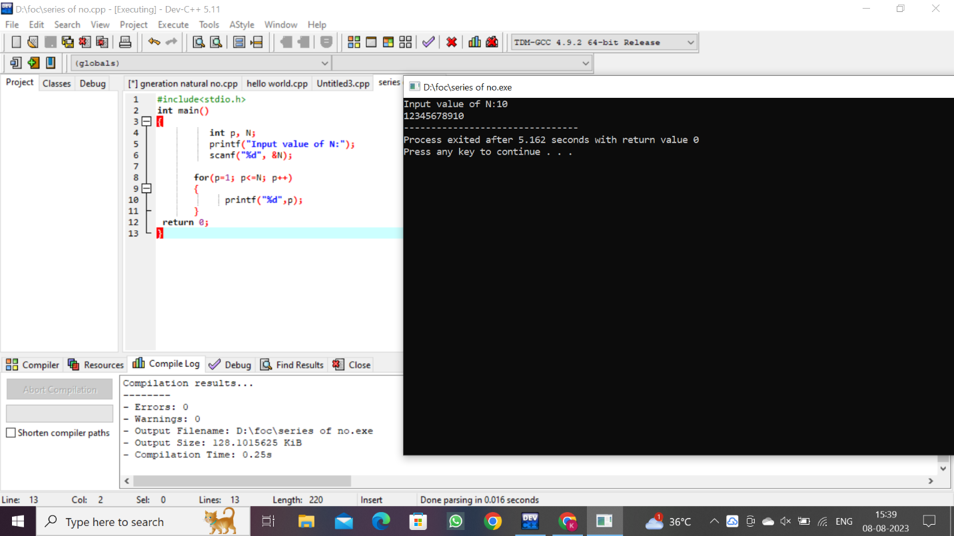2.GENERATION OF EVEN NO OF SERIES 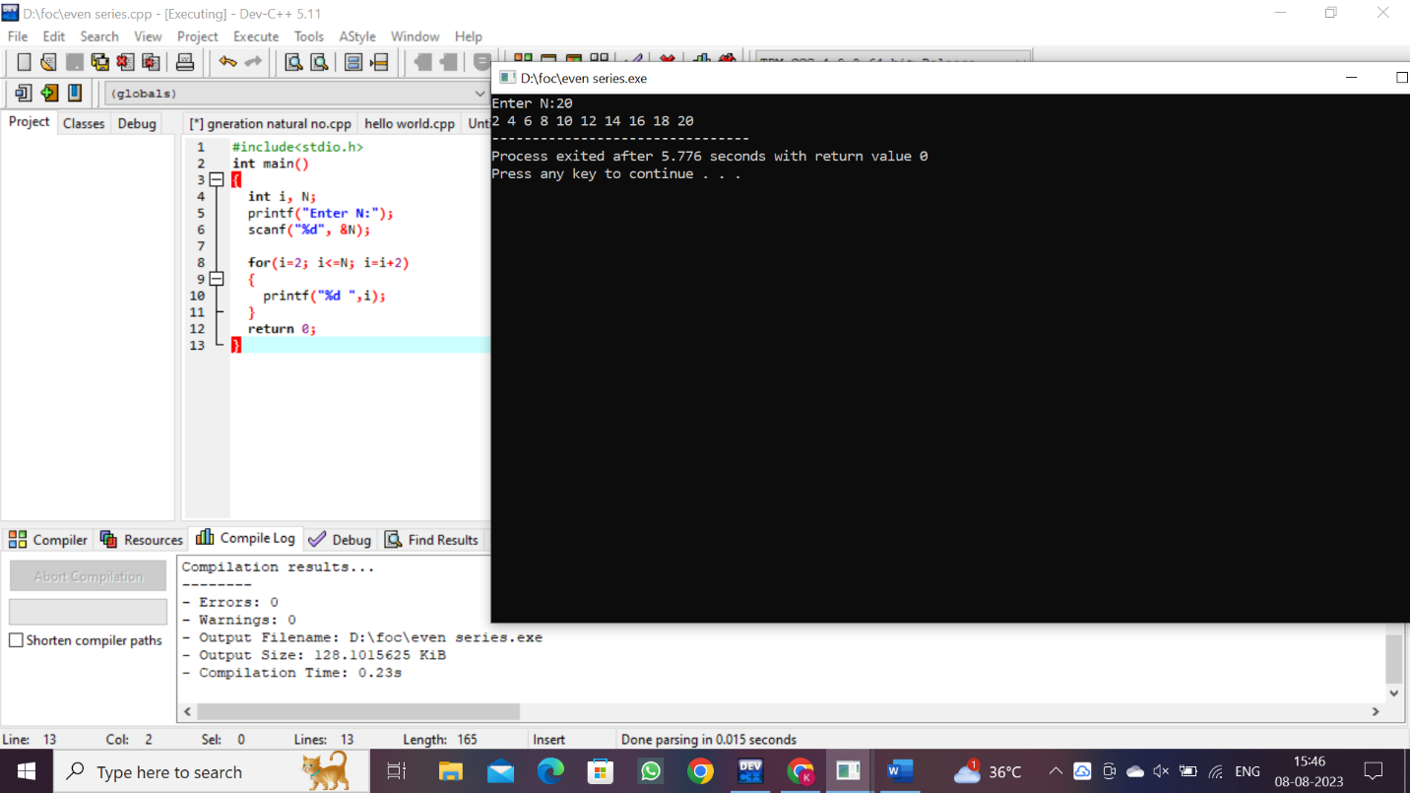

3.GENERATION OF ODD NUMBER OF SERIES;

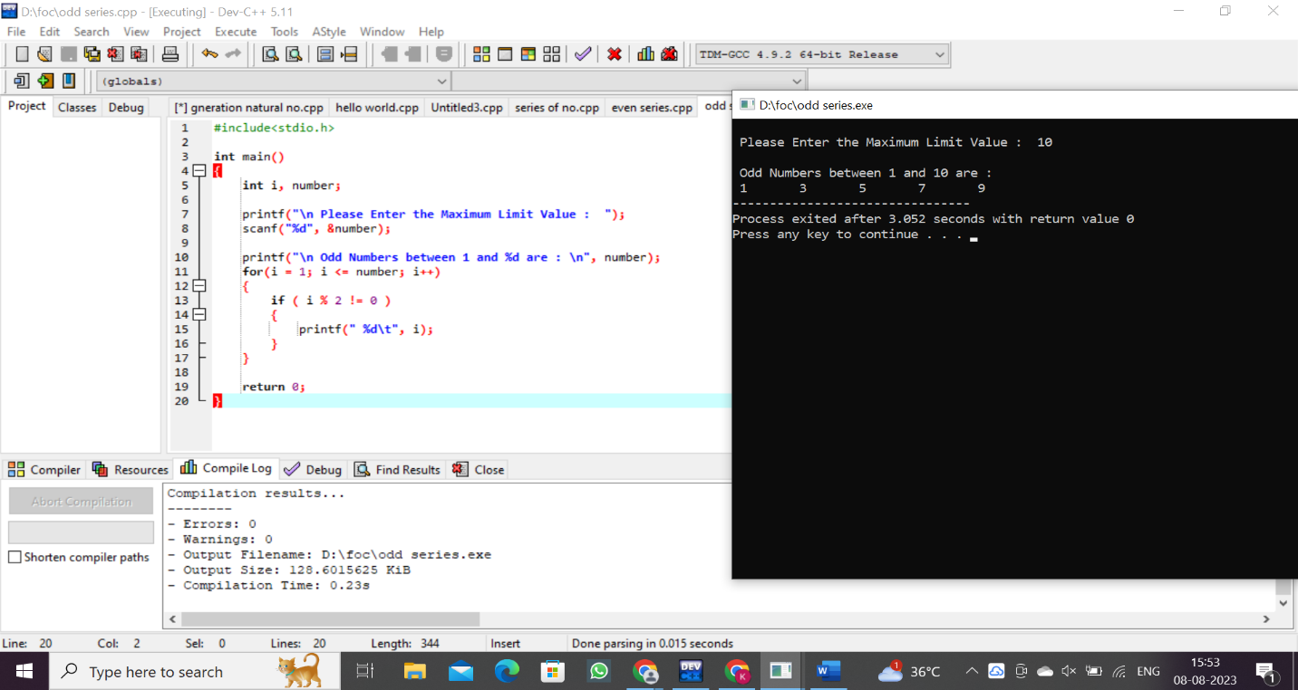

4. Generation of Fibonacci series 0, 1, 1, 2, 3, 5, 8, …..n

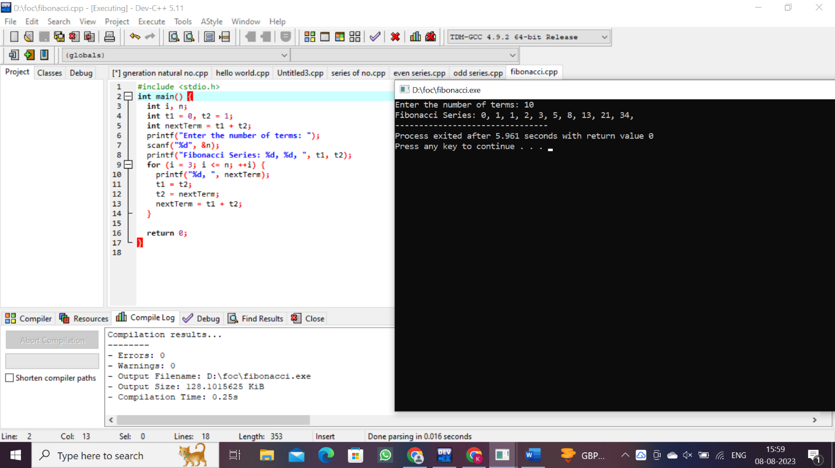

5. Summing up series 1 + 2 + 3 + 4….. +n

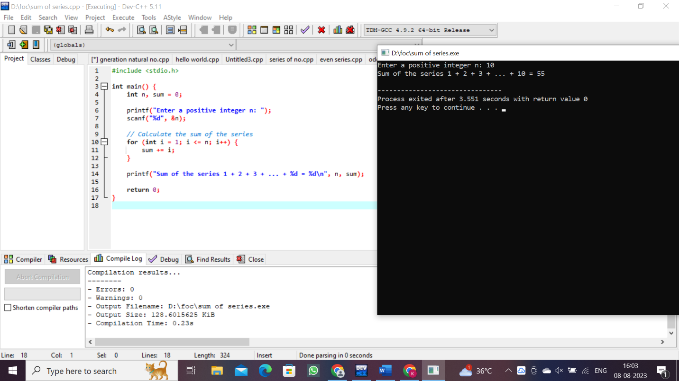

6. Summing up Even Number series

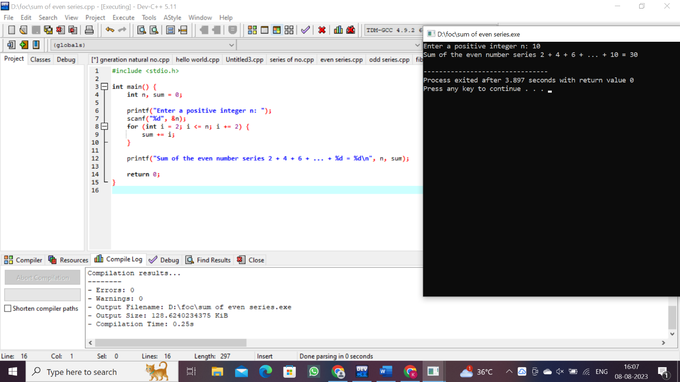

7. Summing up Odd Number series

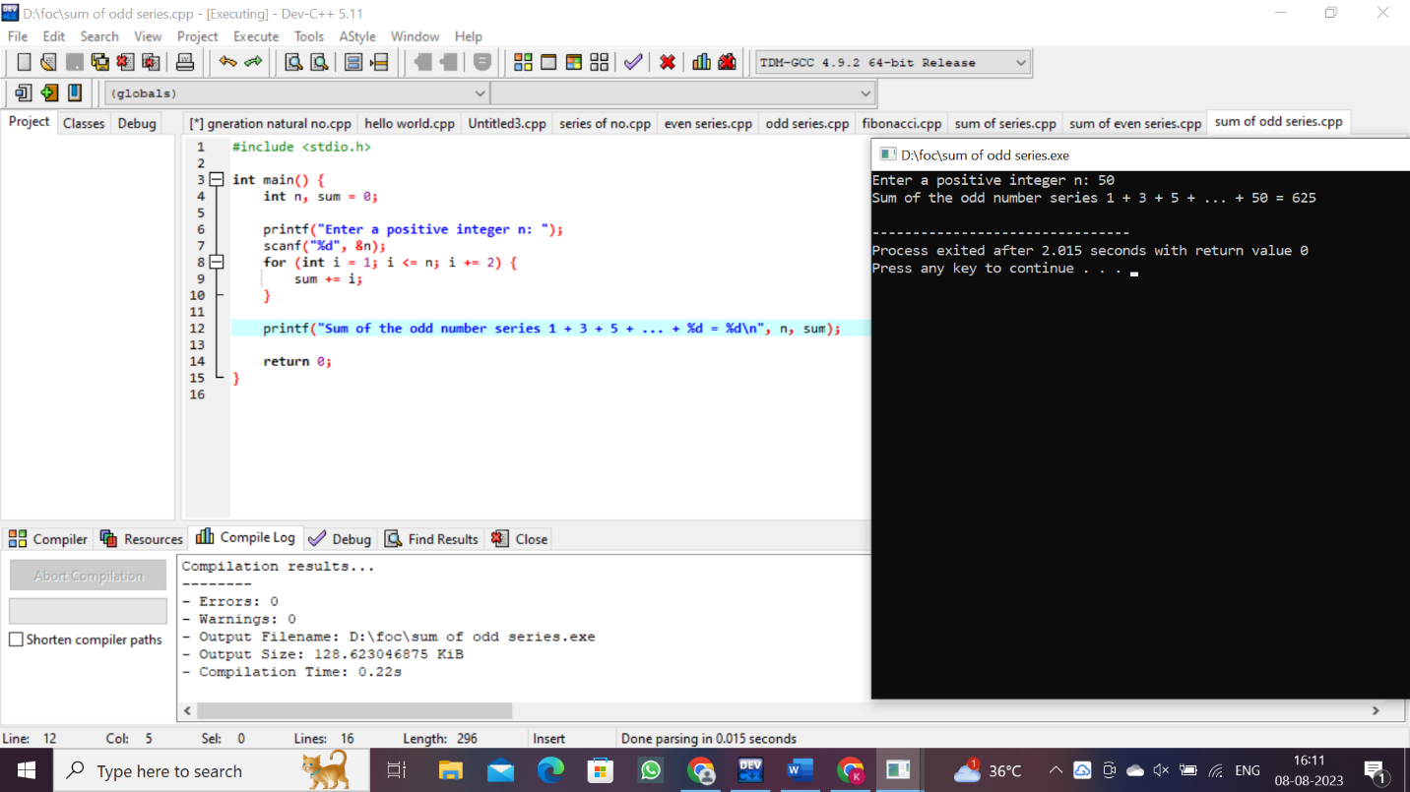

8. Summing up 1 – 2 + 3 – 4 + 5…. N

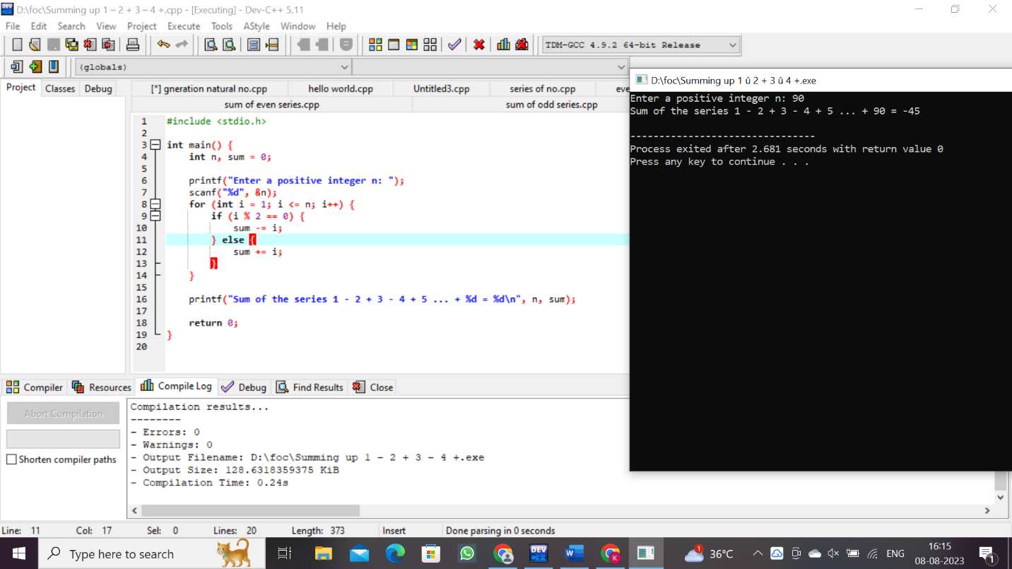

9. Summing up squares of natural numbers 1 + 2 + 3 + 4….. +n

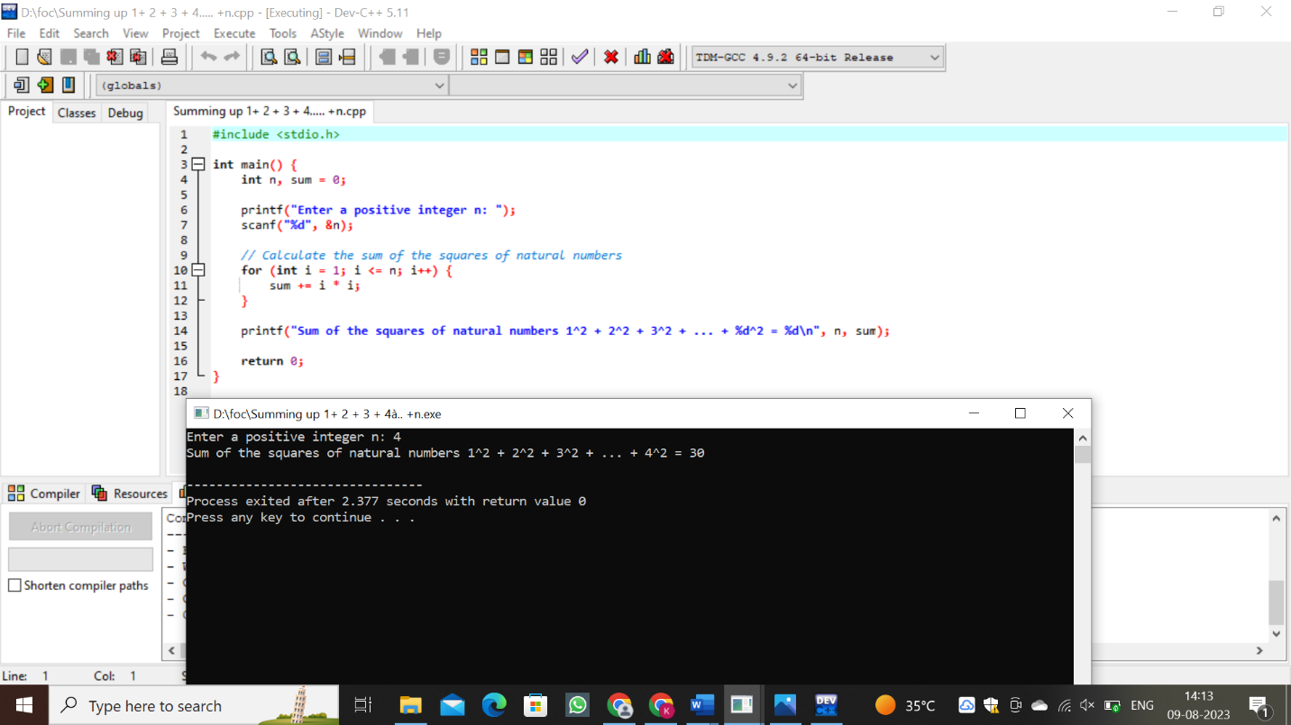

10. Summing up squares of natural even numbers 2 + 4+ 6+ 8 + ….. n

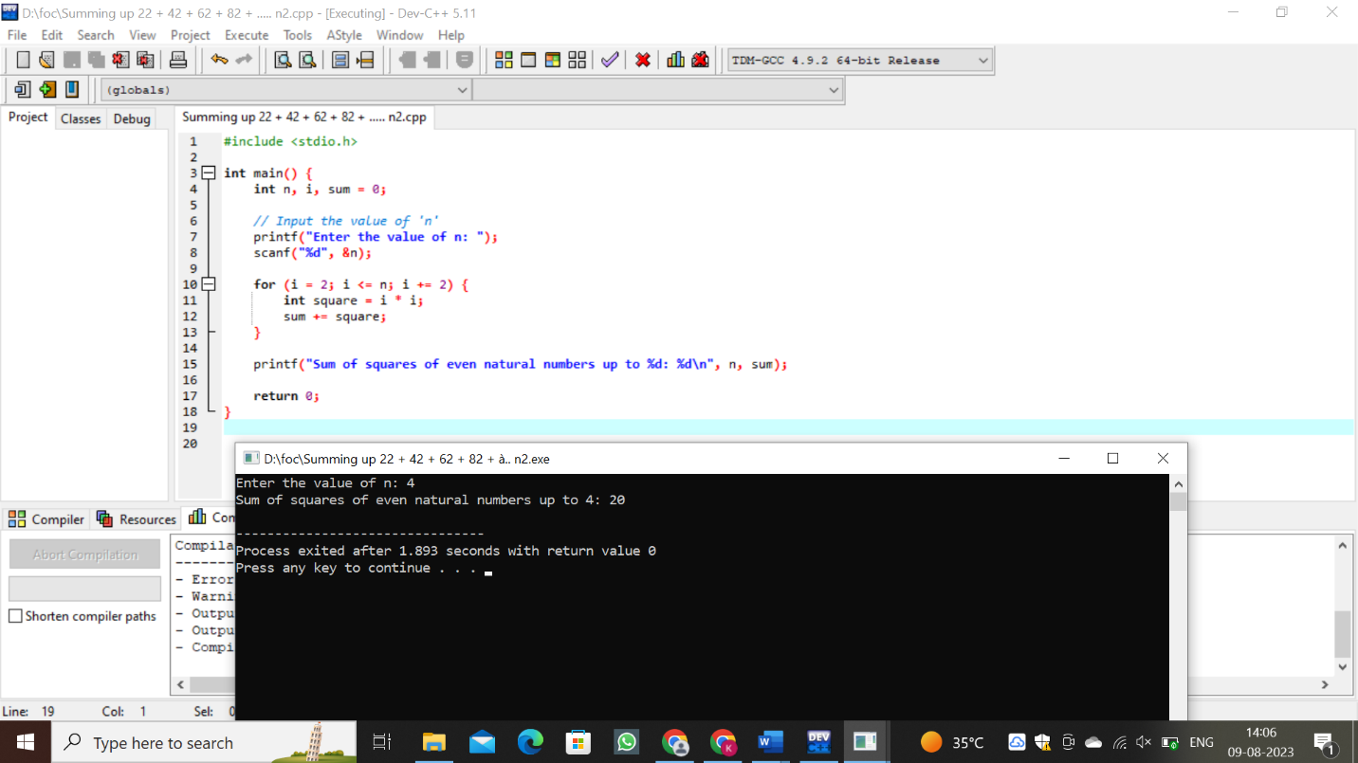

11.simple interest

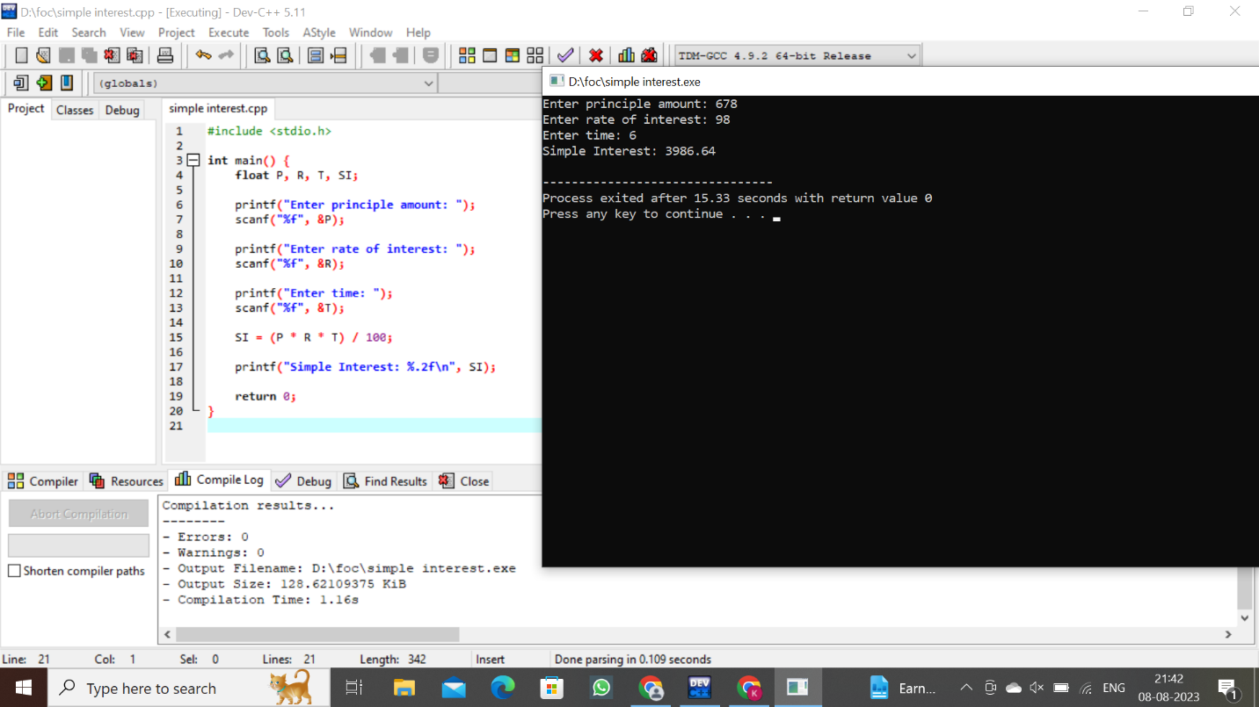

12.negative number

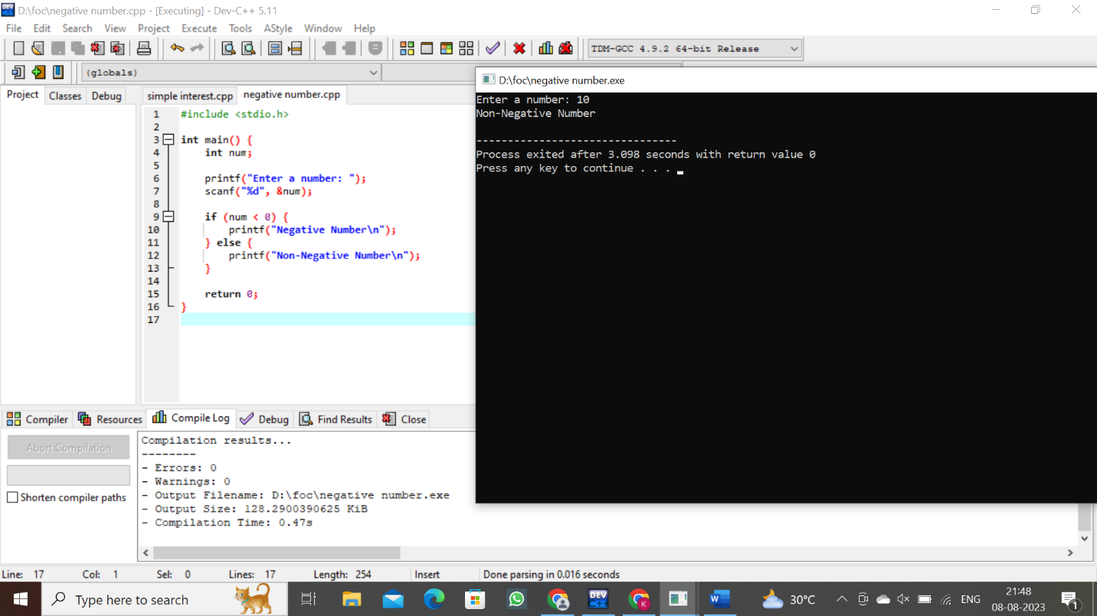

13.calculator

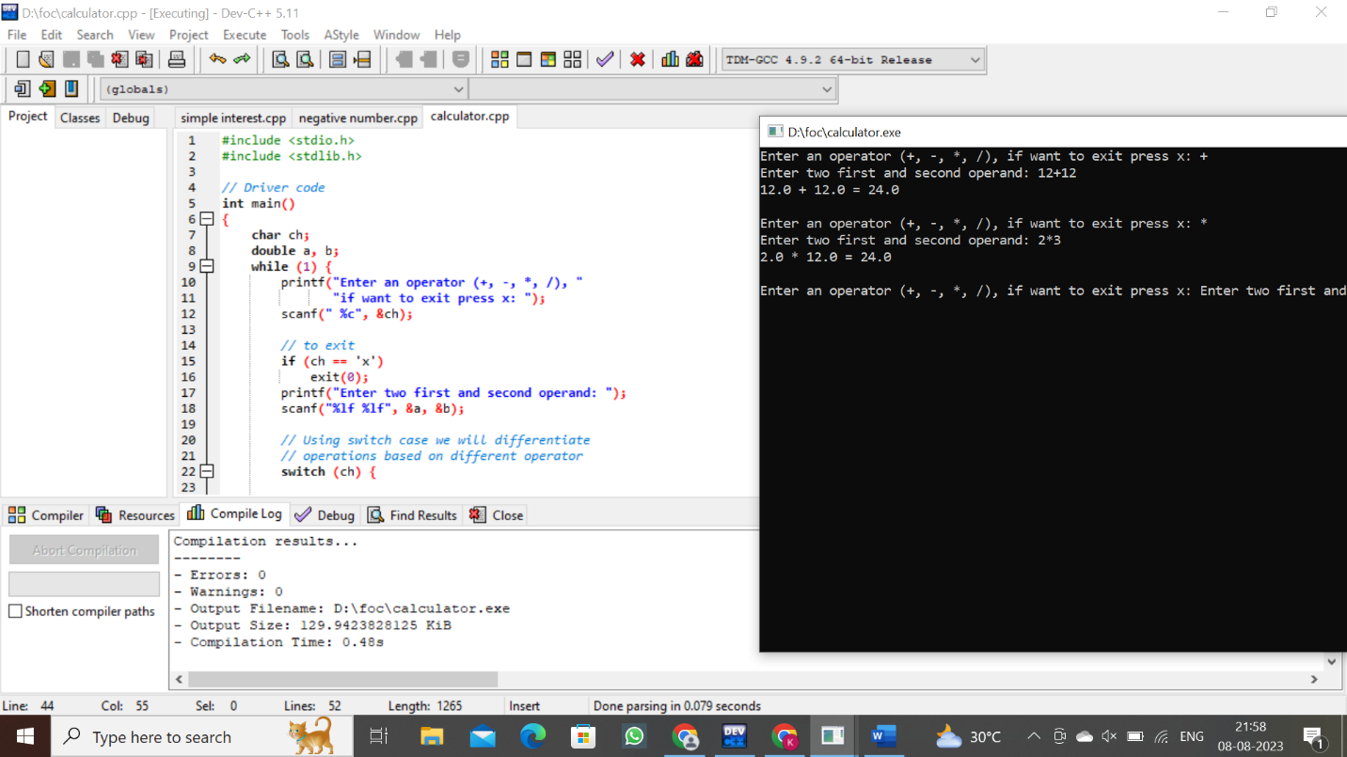

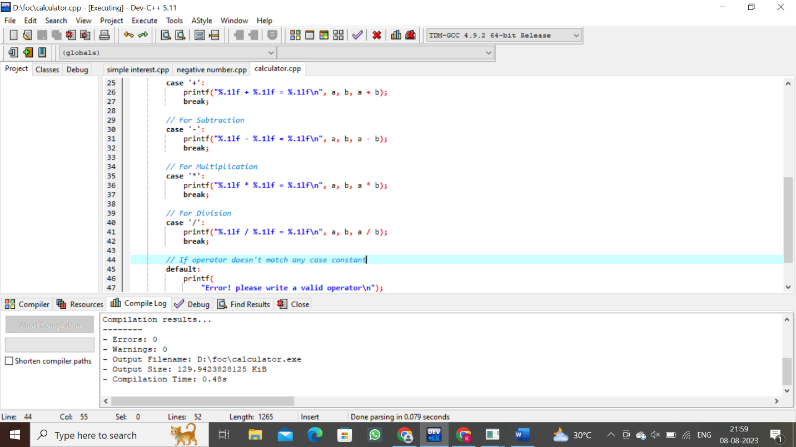

14.conversion of binary to decimal

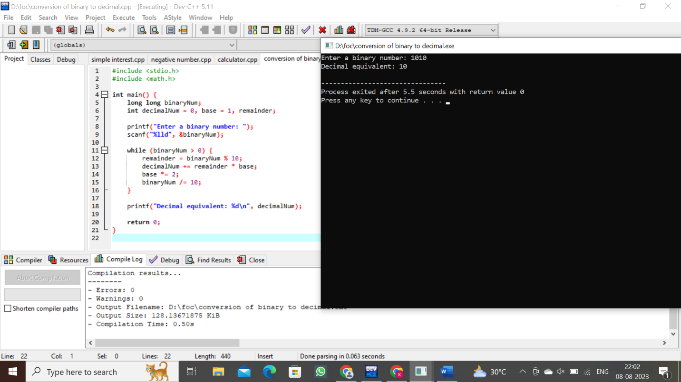

15.conversion of decimal to binary

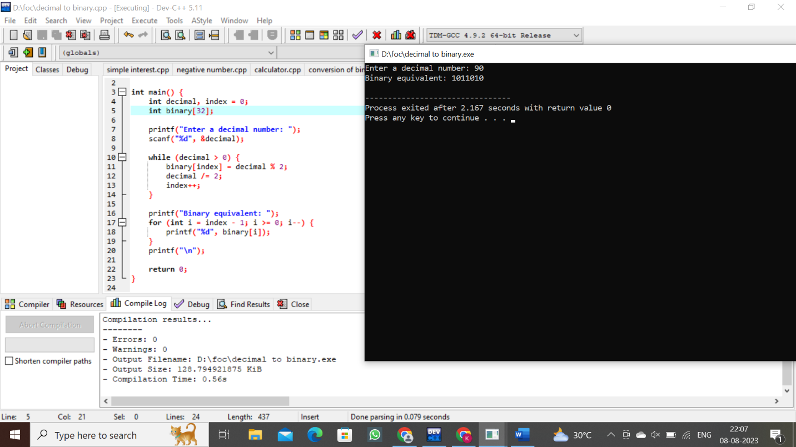

16.elements from array and its display position

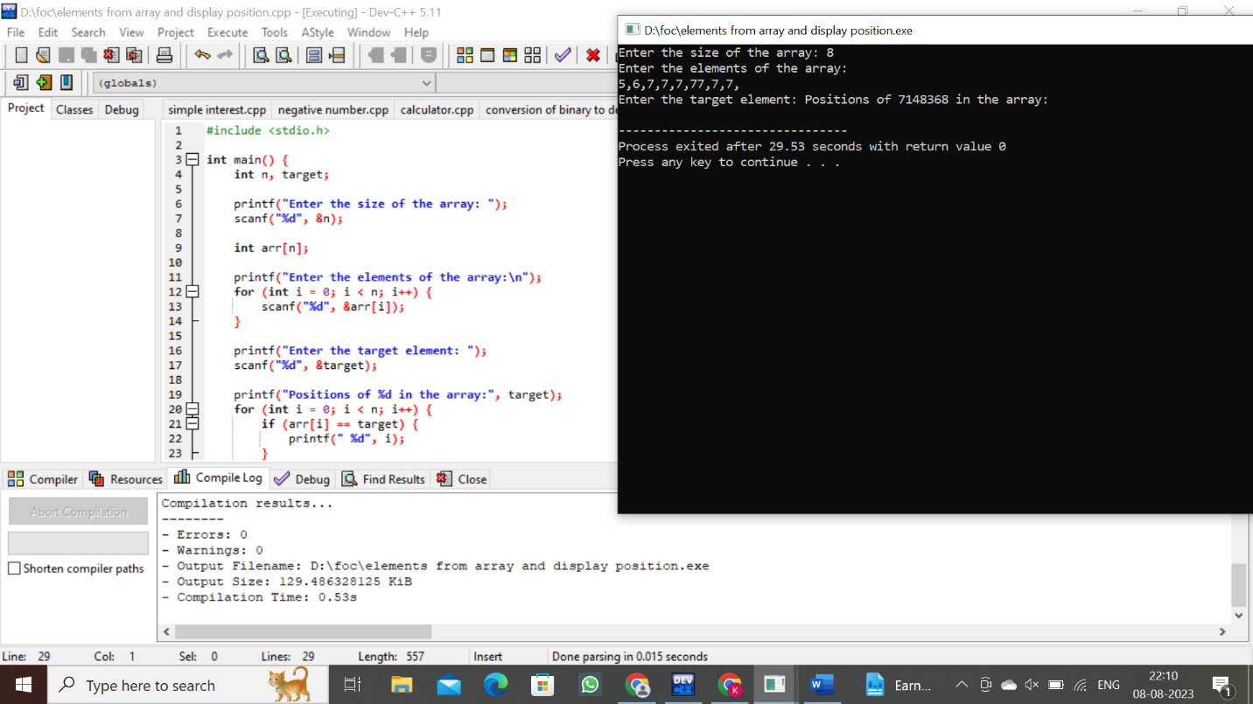

17.length of a string

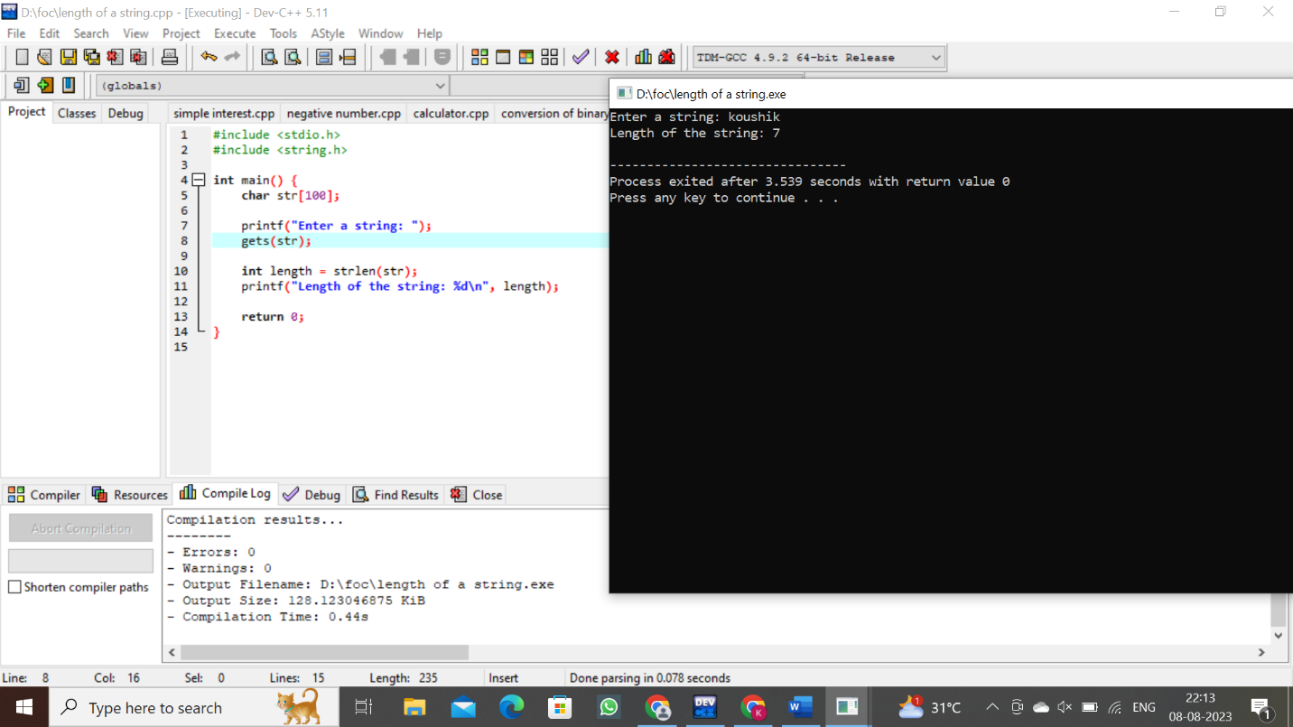

18.pattern

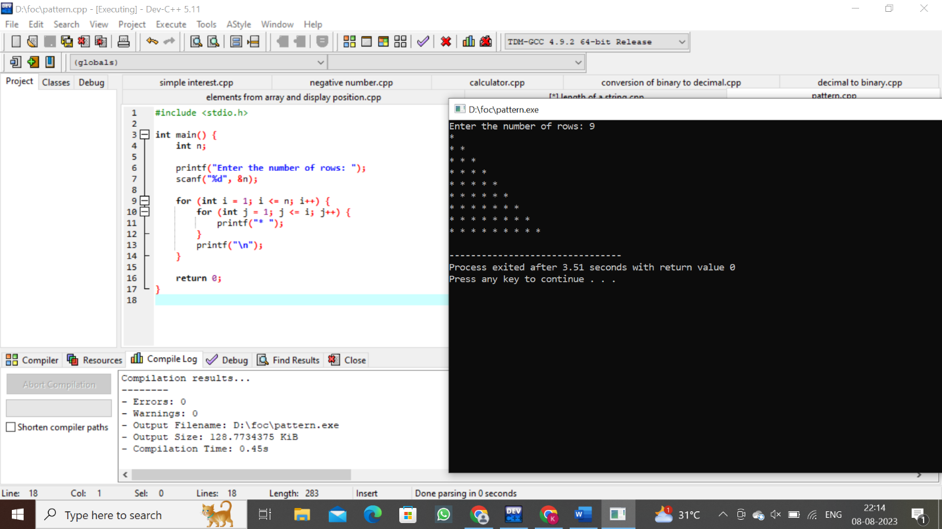

19.sum of elements in an array

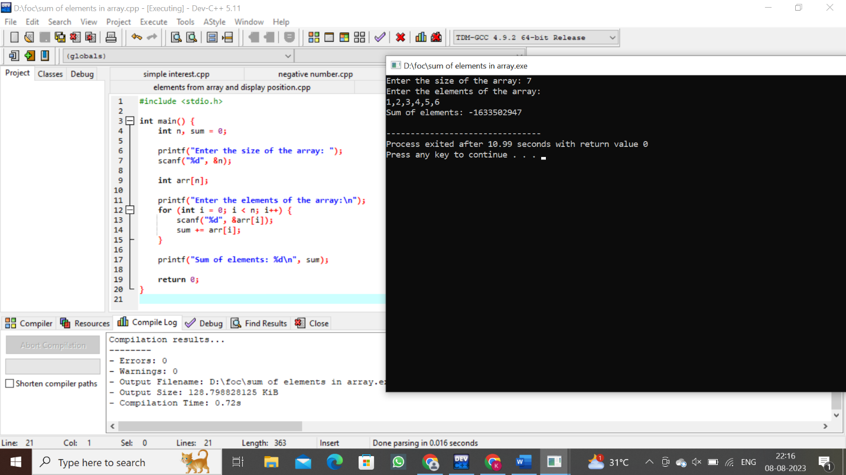

20.merge elements in array

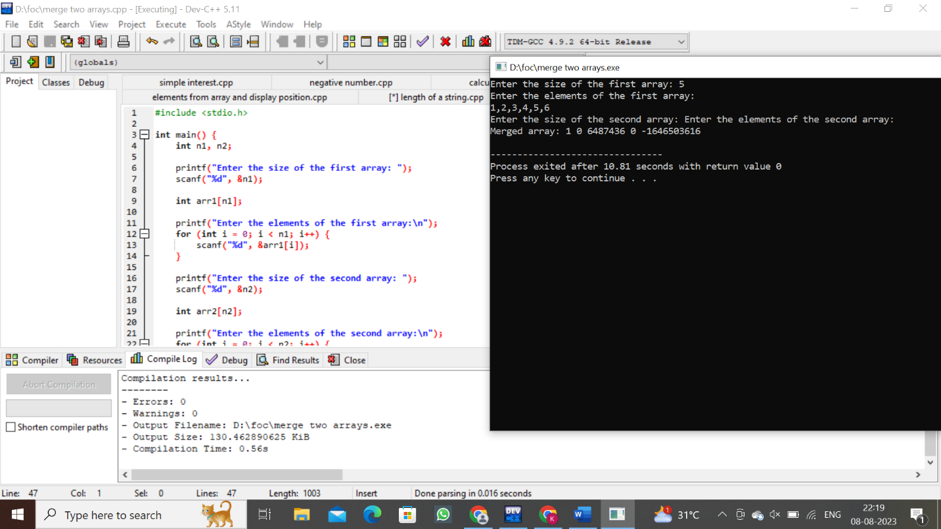

21. summing of no’s by squaring of with same no

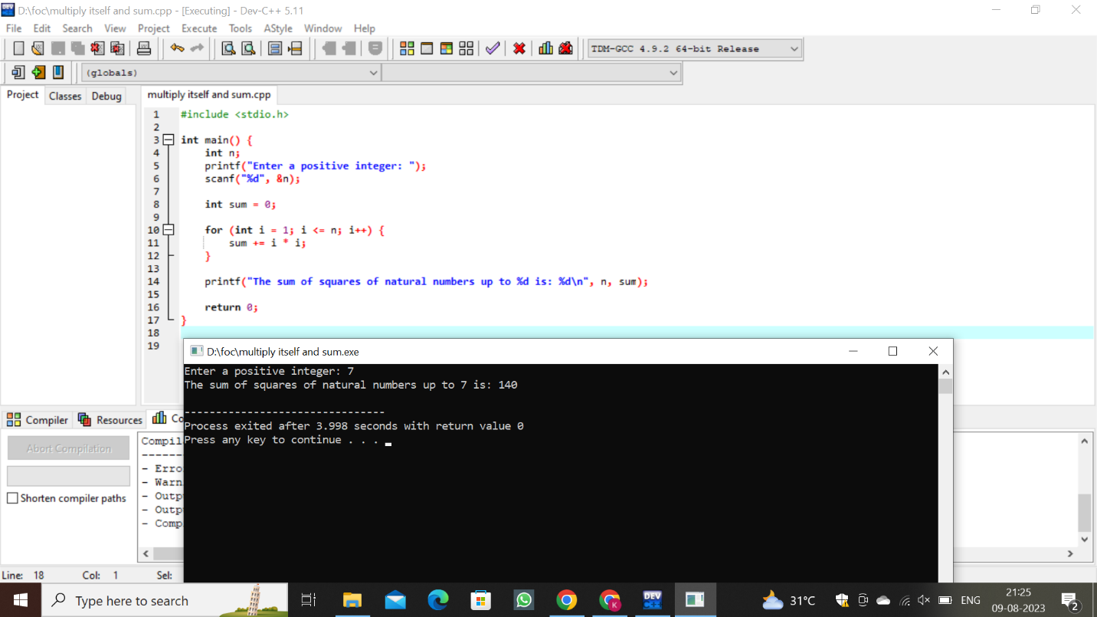

22.summing of squares of odd no’s

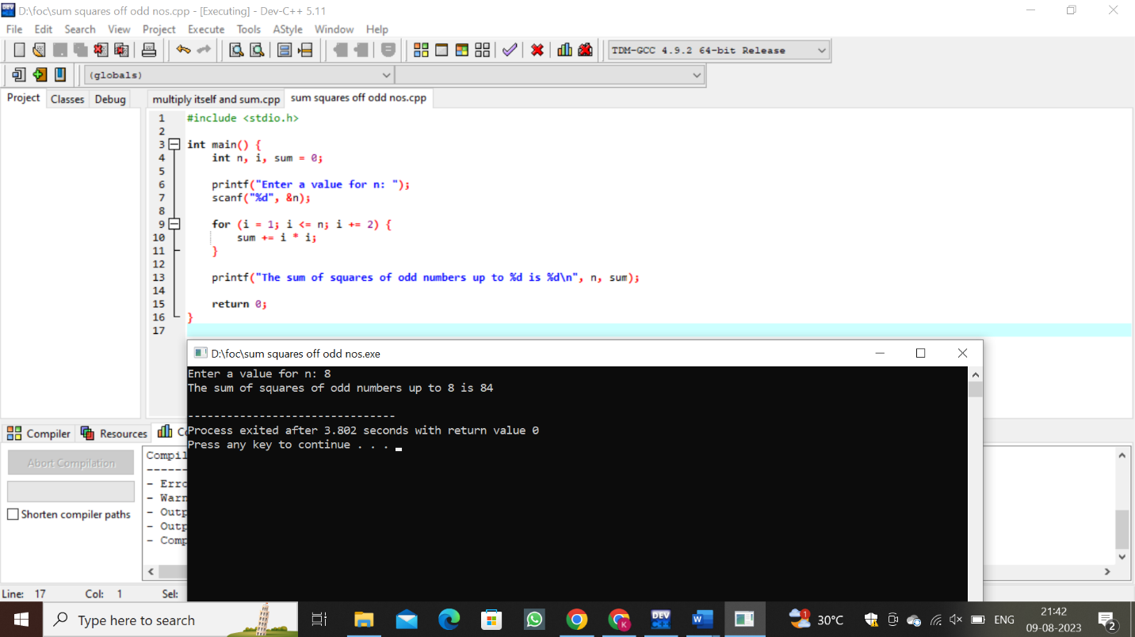

23.summing up cubes of n numbers

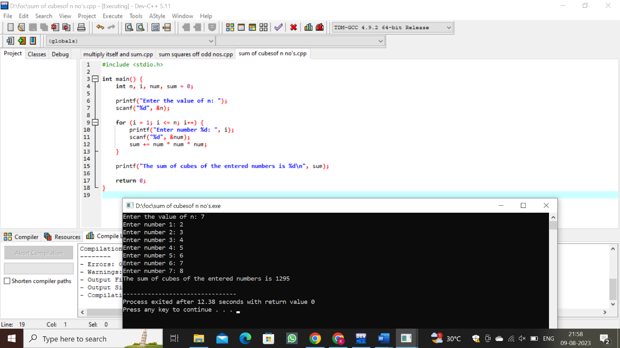

24.product series

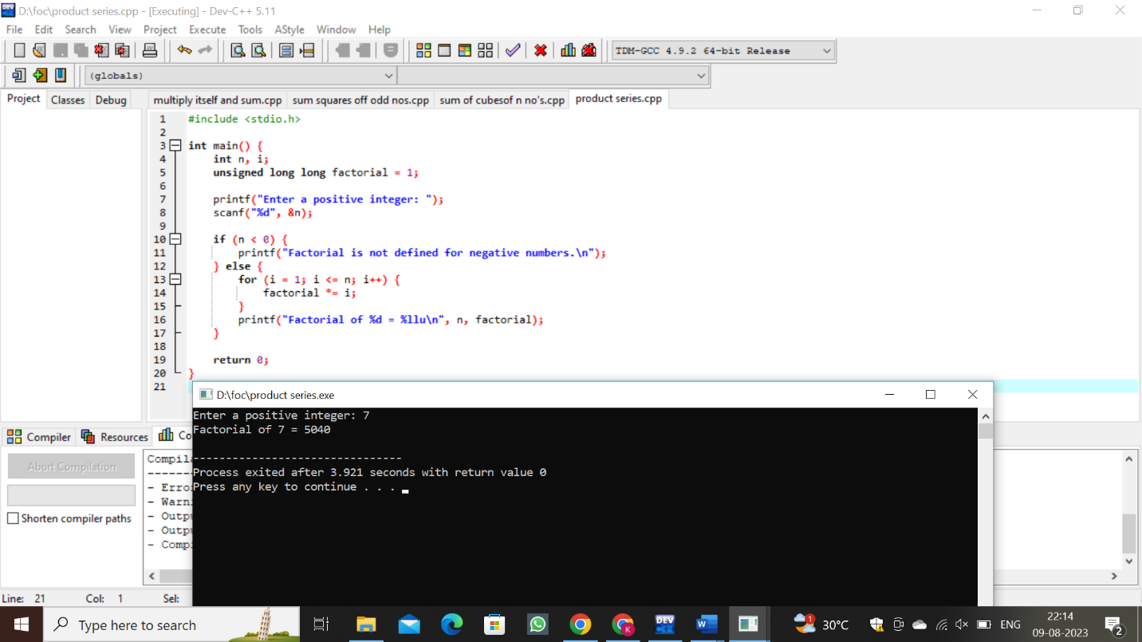

25.finding given num is Armstrong number or not

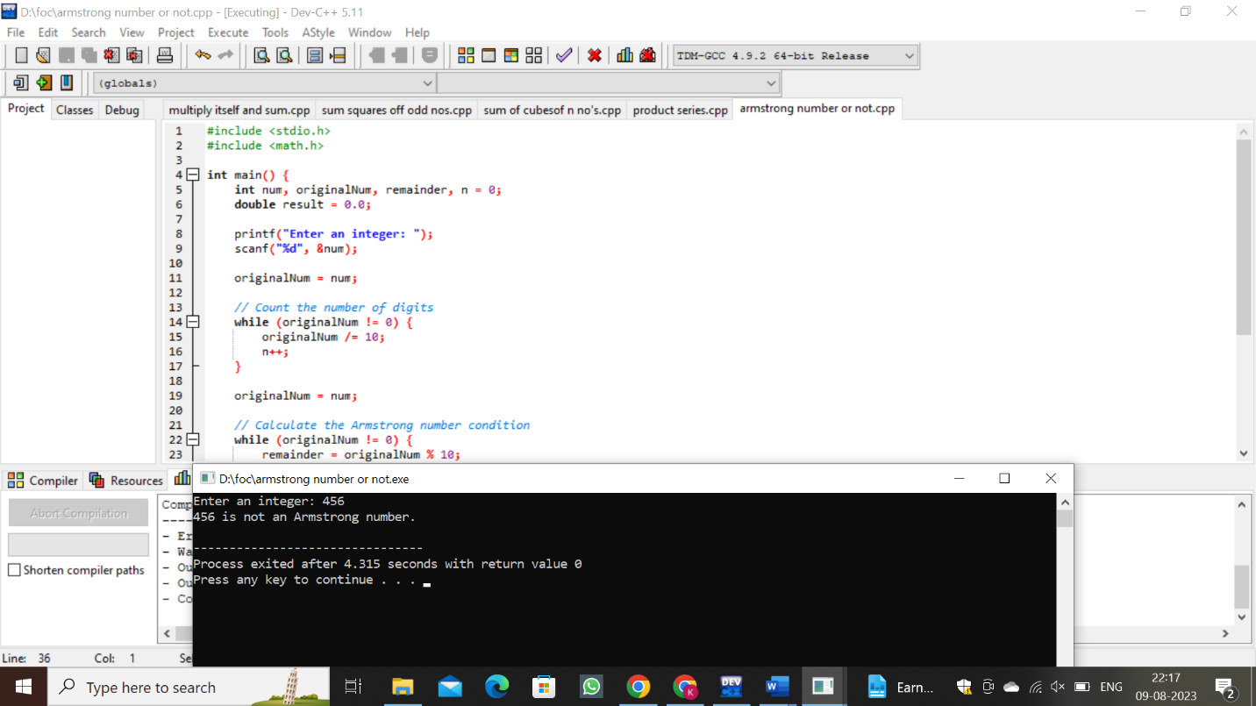

26.summing up any nos and finding average

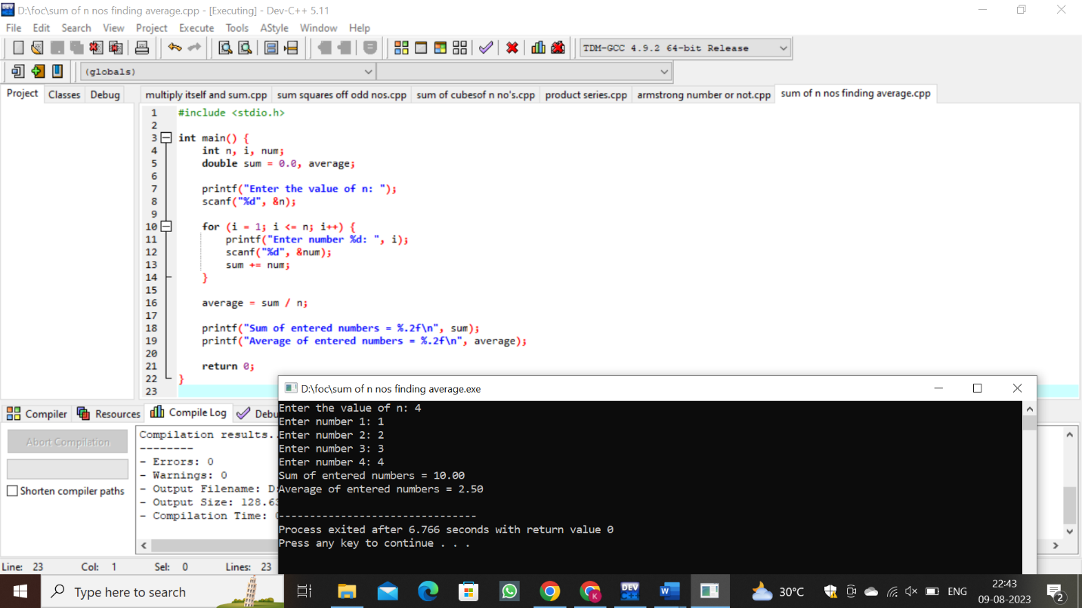

27.printing of the digits of the number

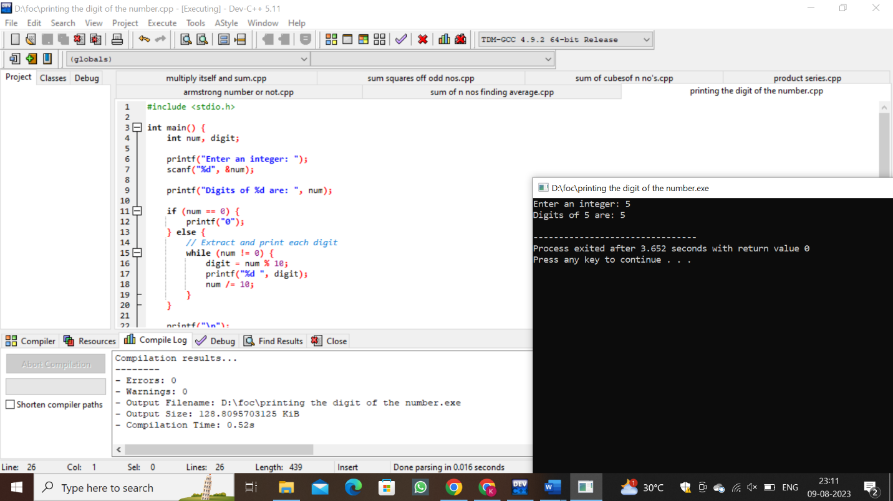

28.summing up of digits of an integer

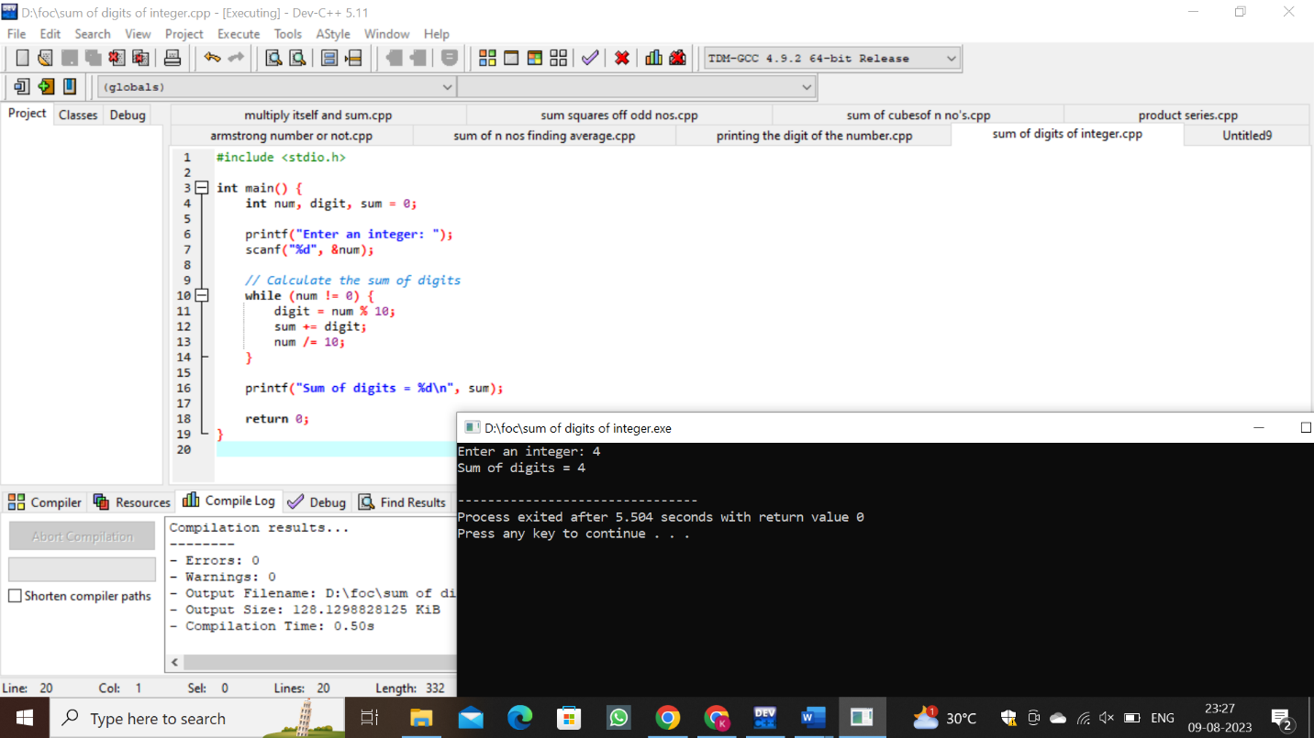

29.reversing the digits of an integer

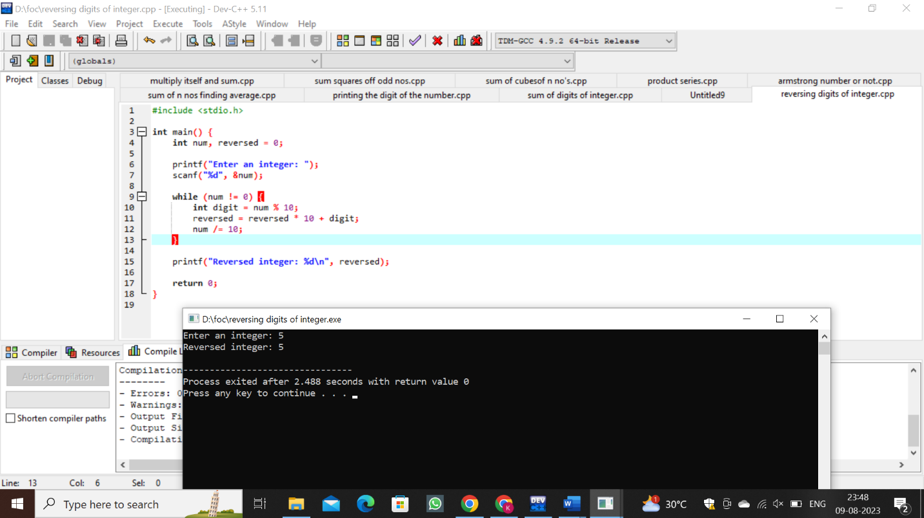

30.finding the element is odd or even

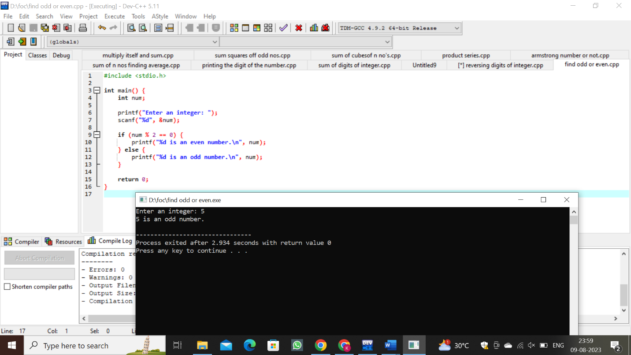

31.transpose of a matrix

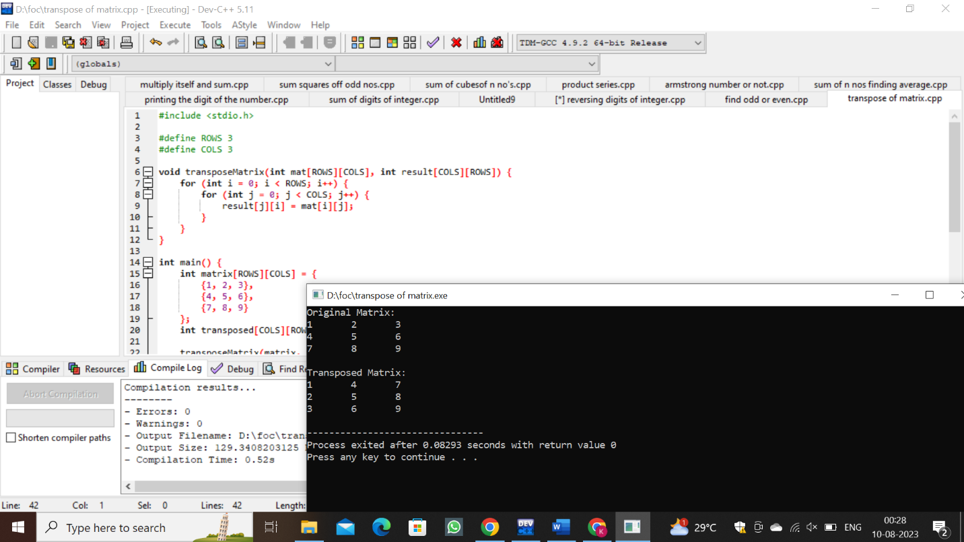

32.square of decimal

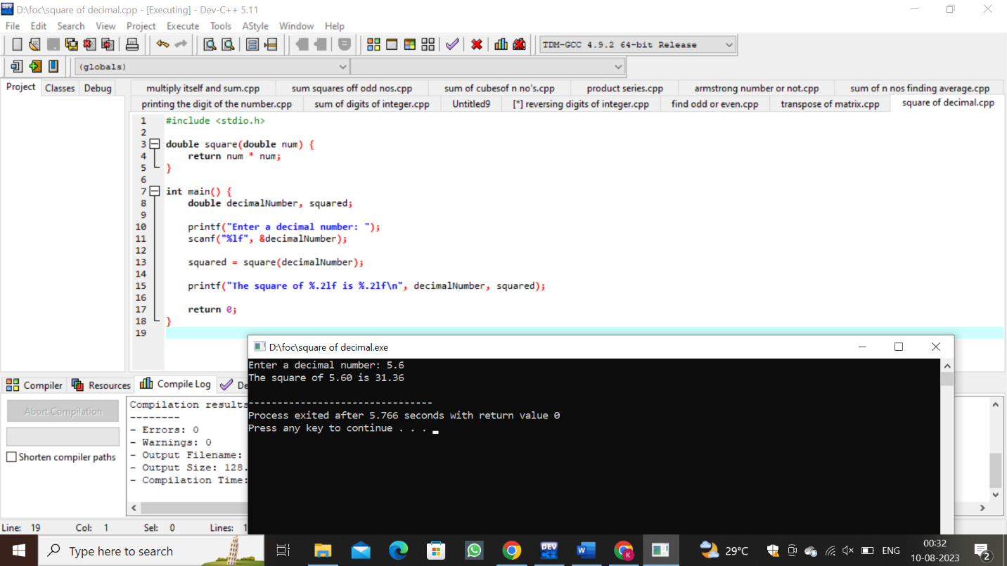

33.cube of decimal

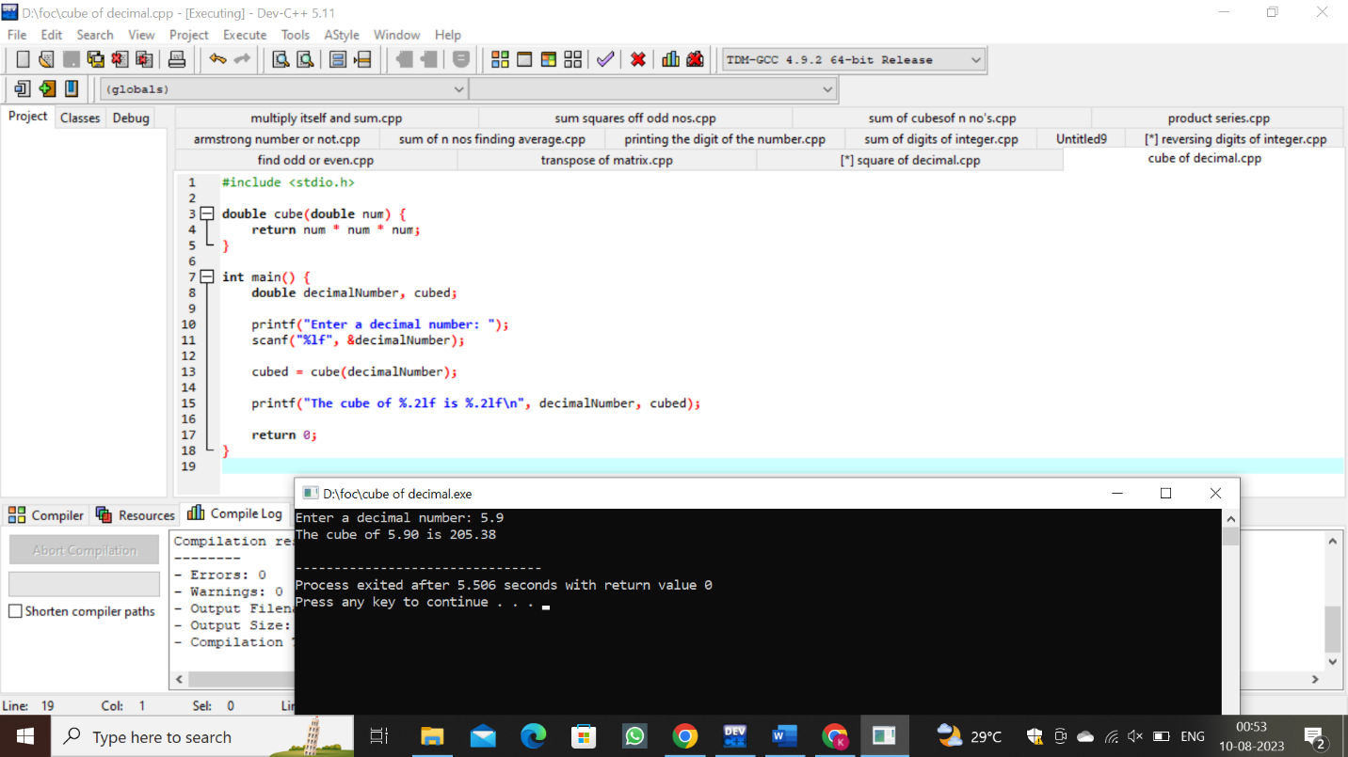

34. multiplication table

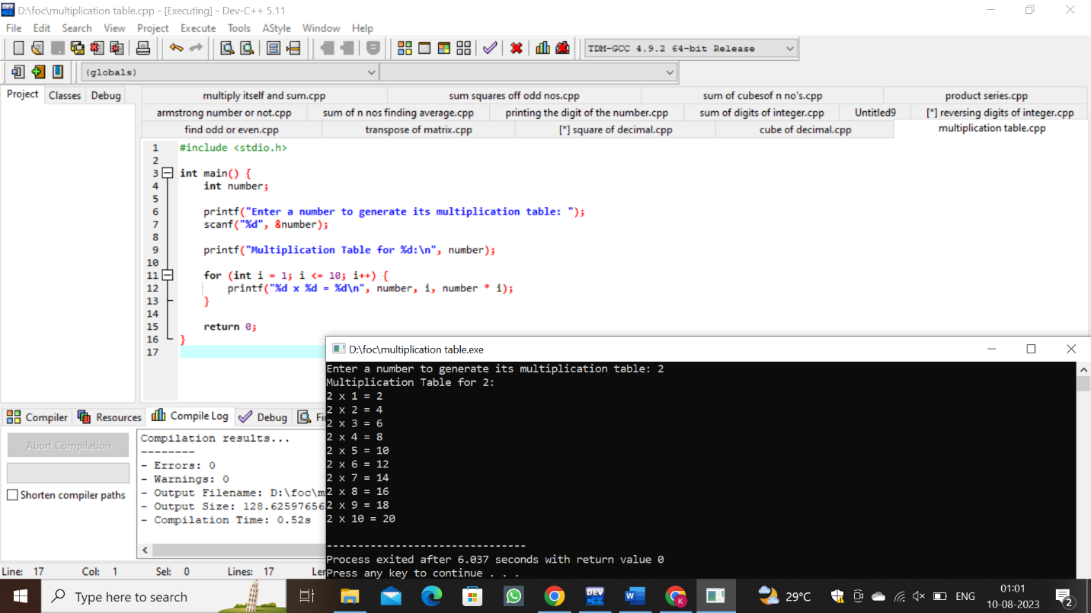

35.finding the given integer is positive or negative

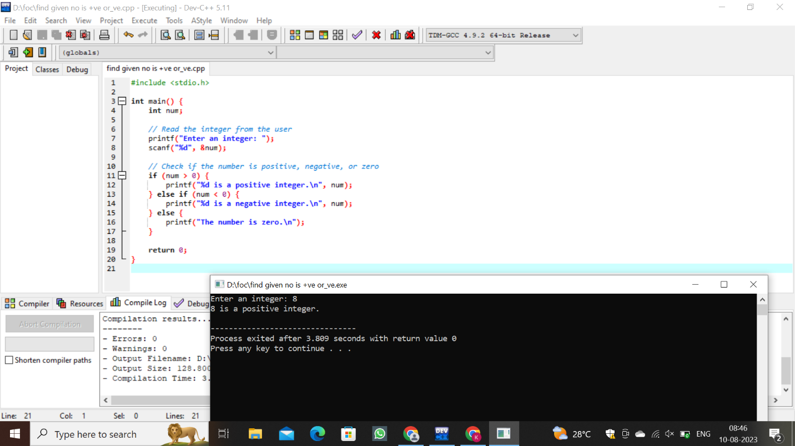

36. Swapping two numbers with a temporary variable

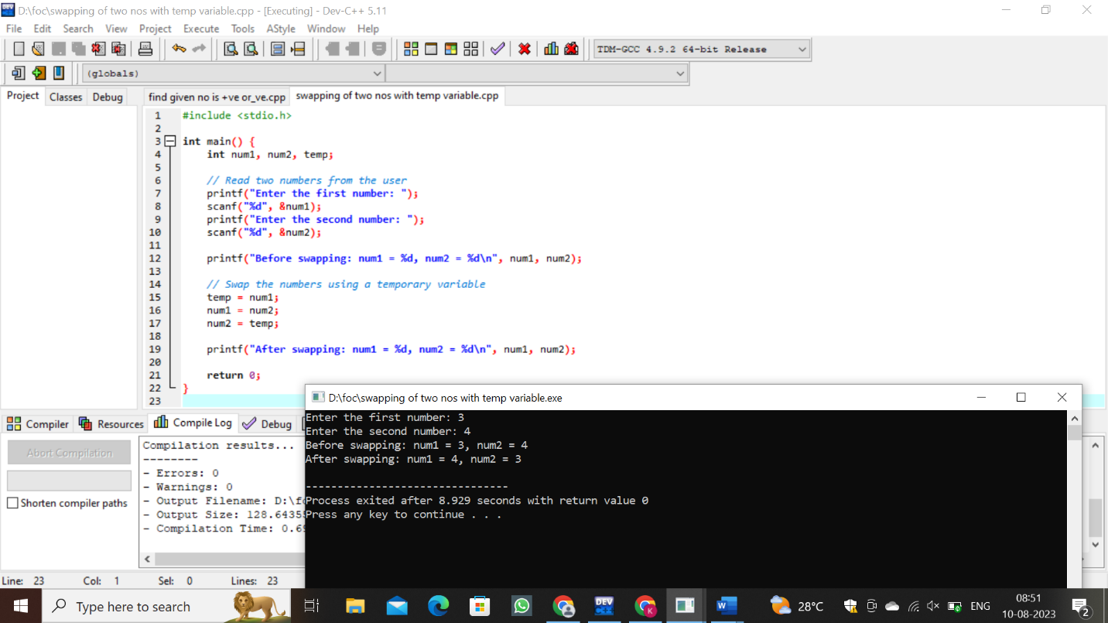

37.swapping of numbers without variable

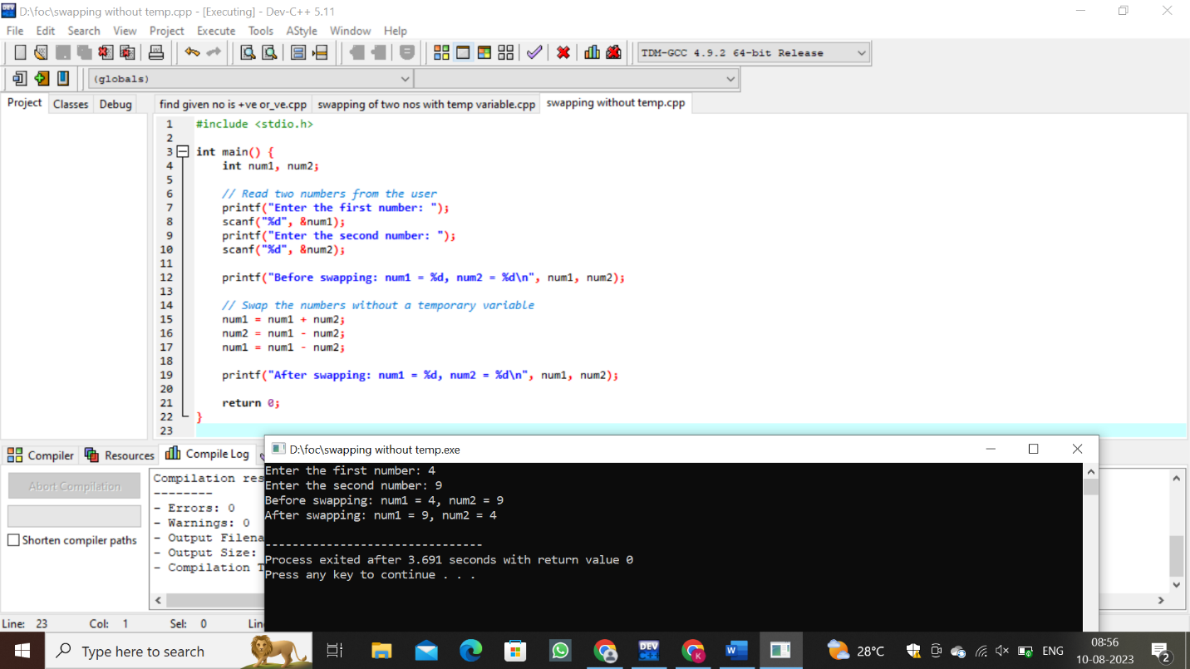

38.swap 3 numbers a,b,c

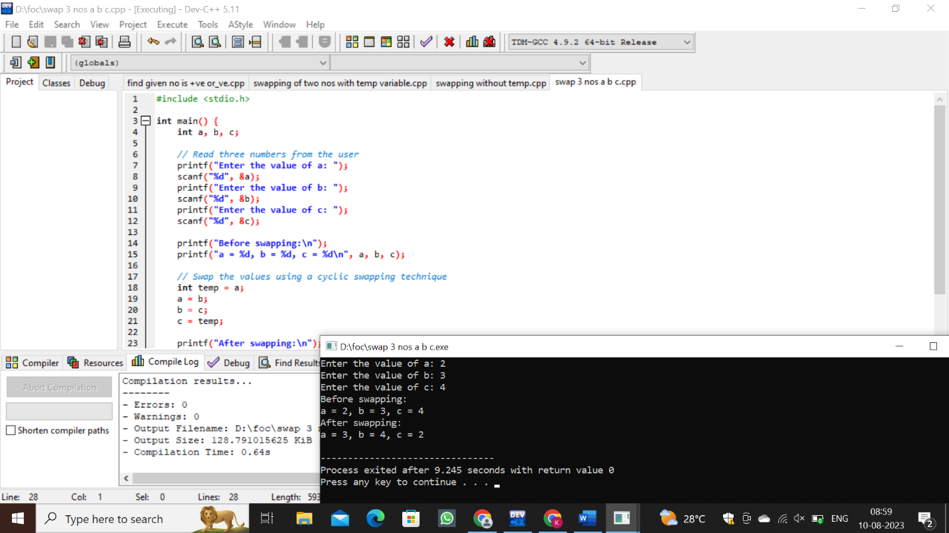

39.find biggest of two integers

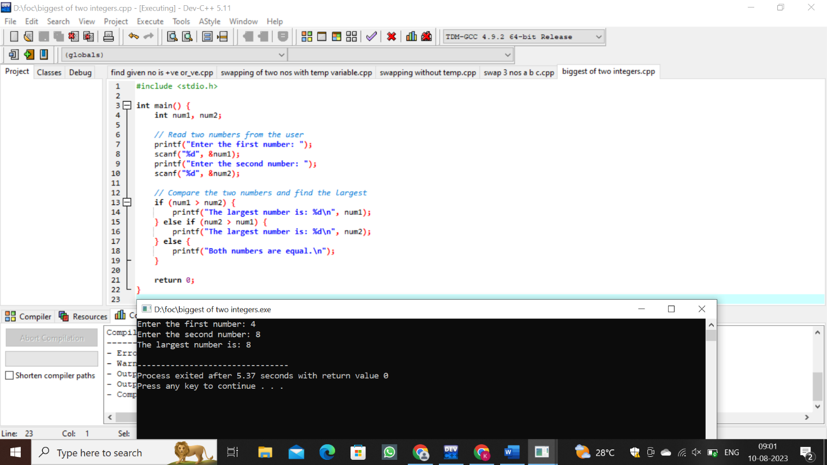

40. Finding the biggest out of n integers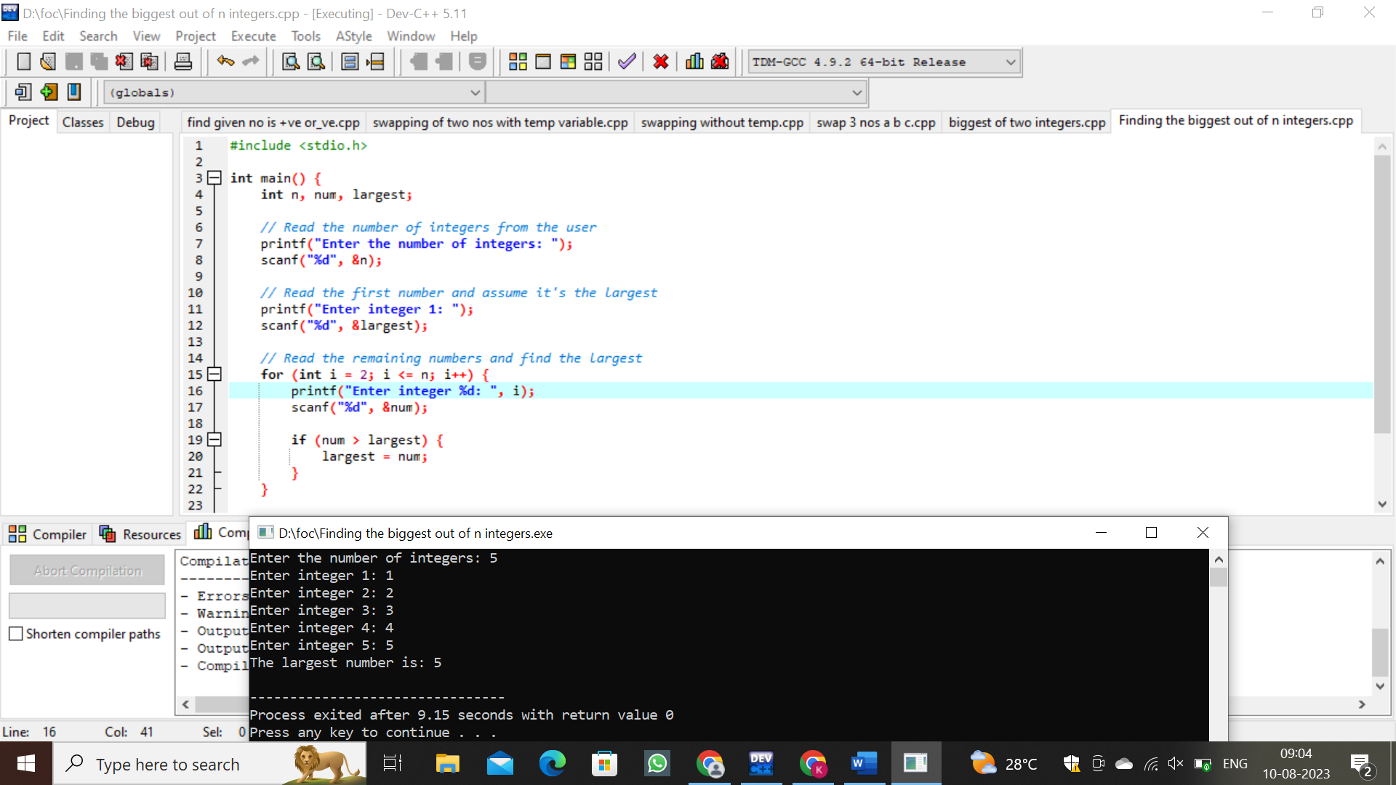

41.sine series

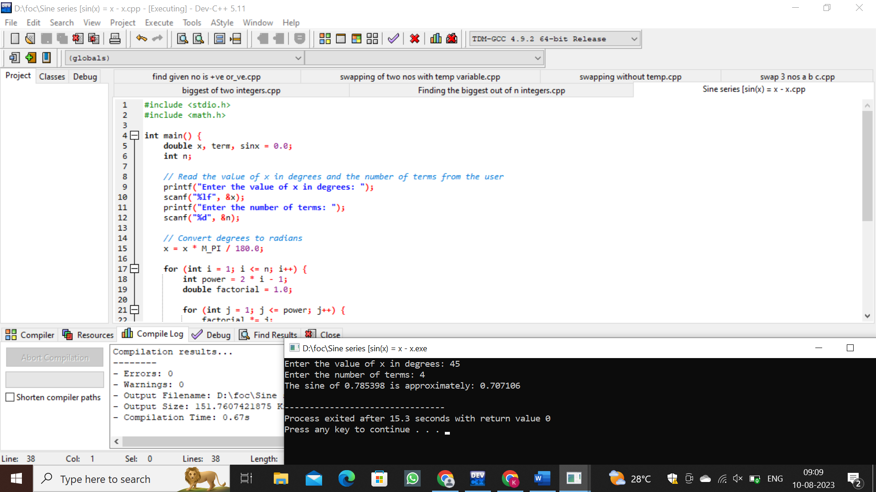

42.cos series

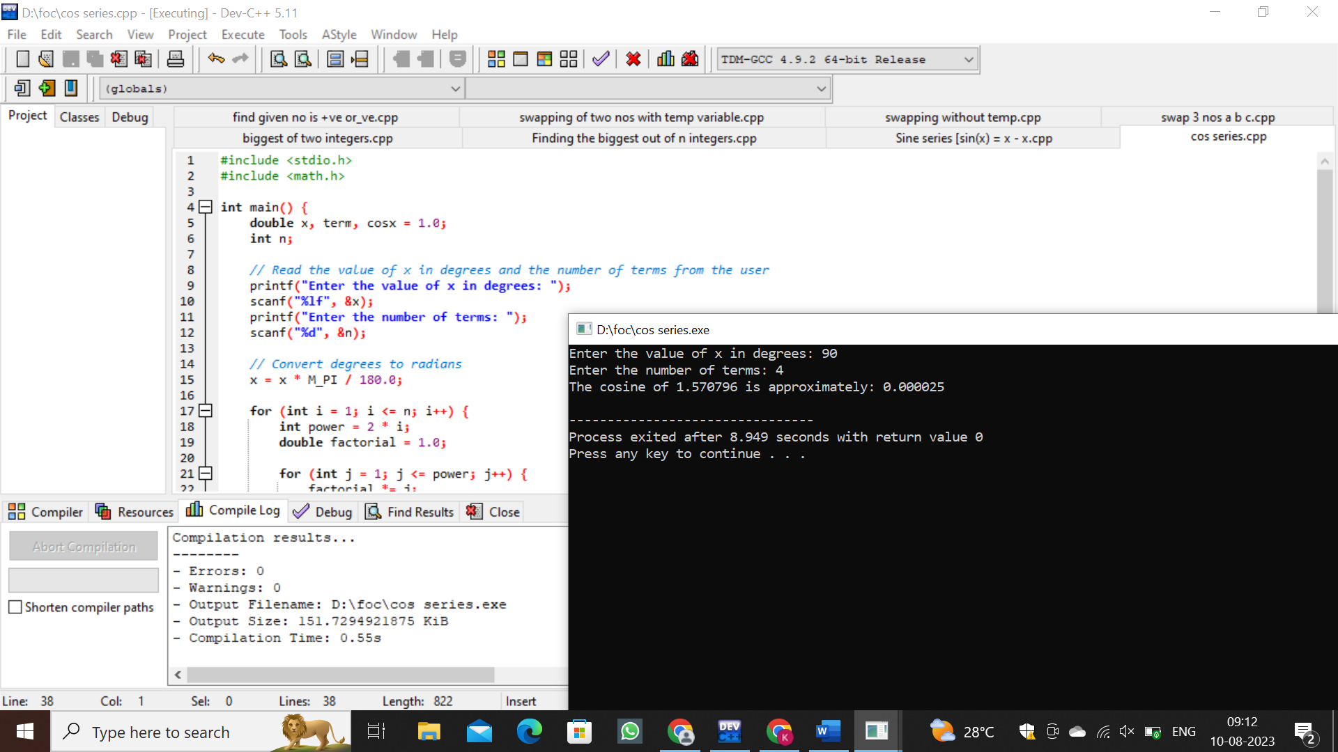

43.exponential series

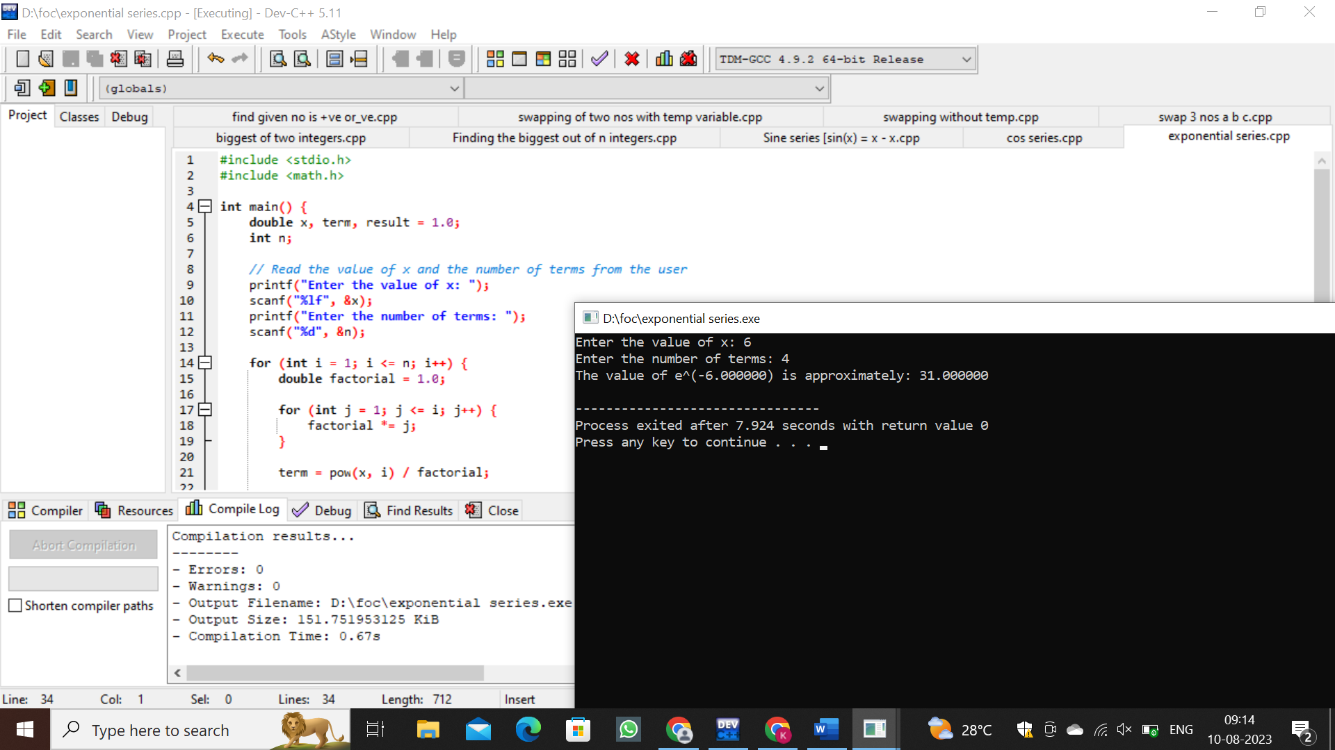

44.linear search

